**Database Management Project**

**Deliverable 0: Project Proposal (Initial Setup)**

Kiran Kiran

**Written Proposal for Coffee Shop**

***Purpose of the Database***

The proposed database aims to make the operations of a small coffee shop easier and more efficient. It will help manage inventory, customer relationship, sales, and employee records effectively. By bringing all this information together in one place, the database will support better decision-making, improve customer service, and moreover help the business growth.

***Key Functionalities***:

* Inventory Management: inventory management keep track all products, such as coffee beans, pastries, dishes, milk, water and more other items. The system will help monitor stock levels, moreover they provide information about suppliers and send alerts when it,s time to recorder, we always have to ensure we always have enough inventory.
* Sales Management: Sales management helps to keep a record of daily sales. It shows how much money the shop makers each day. Moreover, it also helps to find the most popular items and it shows at what the shop is the busiest.
* Employee Management: Employment management keep track of employee details like their shifts moreover their job roles and one of the main thing that how well they perform. It also connects employees to the sales like they make and how they interact with customers.
* Customer Management: Customer management keeps a record of customer details like their contact information, order history and also their loyalty points. This helps to create special offers for customers and moreover build loyalty programs.

***ENTITIES:***

1. Customers:
   1. Customer
   2. Name
   3. Contact info
   4. Loyalty Points
   5. Order History
2. Orders:
   1. Order ID
   2. Customer ID
   3. Employee ID
   4. Order Date
   5. Total Amount.
3. Product:
   1. Product ID
   2. ProductName
   3. Price
   4. Category
4. Employees:
   1. Employee ID
   2. Name
   3. Role
   4. Hire date
   5. Shifts Schedule
   6. Performance ratings

**Key Reports**

* Monthly Sales:
* Inventory Report
* Employee Performance Report
* Customer Loyalty Report

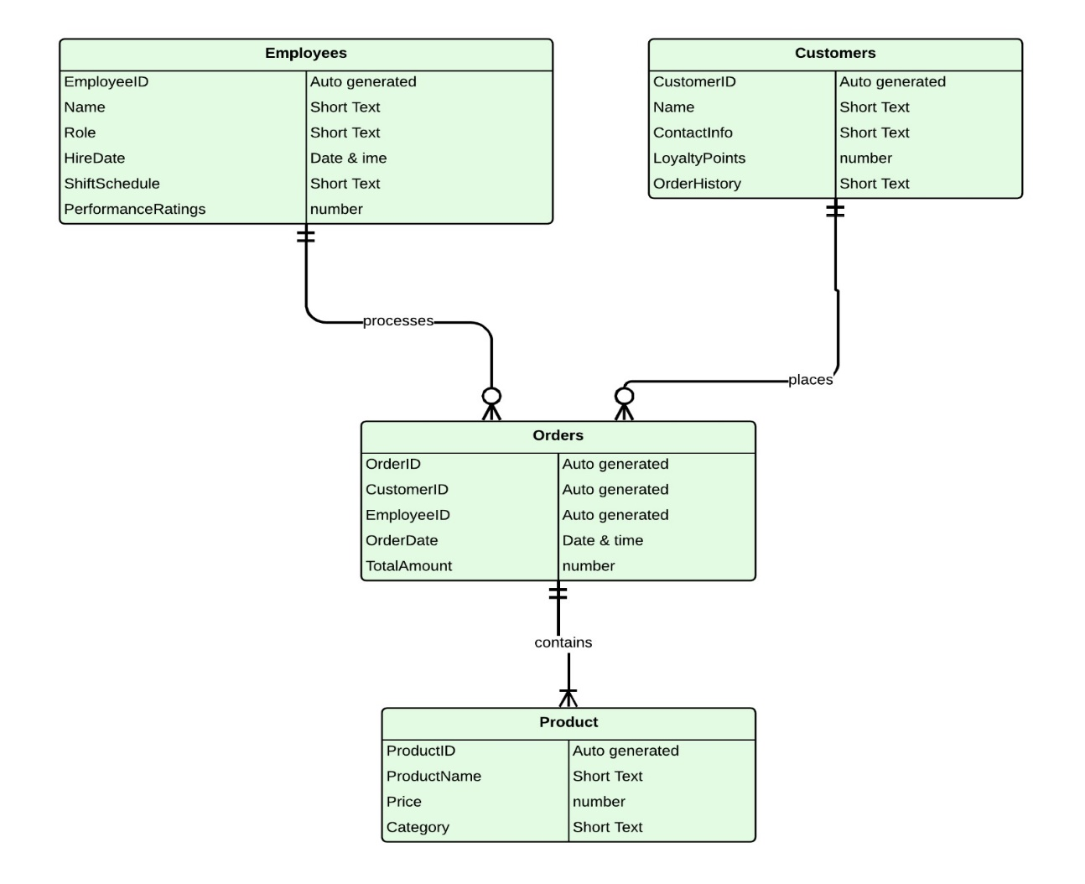***Relationship Diagram***